aim games  
Sprint 2 review

# Summons

|  |  |
| --- | --- |
| Name | Roll |
| De la Fuente Bonilla, Fco. Javier | **CEO, Project manager** |
| Molina Domínguez, Jorge Manuel | **CCO,CIO** |
| Bizcocho González, Mario | **CMO, Product Owner** |
| Arenas Arenas, Antonio  Monteseirín Puig, Alejandro  Pazo Jiménez, Pablo  Pérez Piñero, Iván  Santos Batista, Miguel | **Developers** |

# attendee

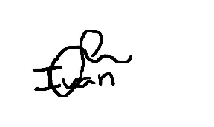**De la Fuente Bonilla, Fco. Javier Pérez Piñero, Iván**

**Arenas Arenas, Antonio Molina Domínguez, Jorge Manuel**

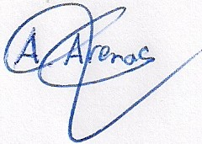

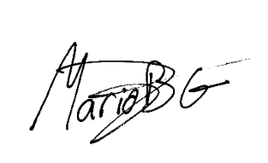**Monteseirín Puig, Alejandro Bizcocho González, Mario**

**Santos Batista, Miguel Pazo Jiménez, Pablo**

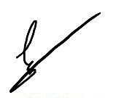

# Absent

No Proceed

# Date and place

Being on Friday April 5, 2019, and verified the attendance of all the summoned, began at 11:15 hrs. To the Sprint review meeting for the AIM GAMES project, which ended at 12:30 hrs.

# AGENDA

1º Review of things created to date and discuss problems that have showed up

# Development of the meeting and agreements

## Review of things created to date and discuss problems that have showed up

During the meeting there was a discussion about how the sprint was going and the biggest problems that were encountered in terms of organization and development.

The main problems was the security risk that we found at the start of the sprint and we decided to create the new user, the solution and its implementation have been satisfactory, and every other user cases of the MVP so we are ready to start the piloting plan after the weekend.

We have decided to assign different test and fixing task to every member to polish the MVP for the delivery of this sprint

# Signed in conformity

